ATM MANAGEMENT SYSTEM
1. Introduction
The ATM Management System is a Python-based application designed to simulate the core functionalities of a traditional Automated Teller Machine. This project serves as a practical implementation of software logic, focusing on secure user authentication, financial transaction processing, and data management using structured programming techniques.

2. Project Objectives
- To create a secure interface for user login using PIN validation.
- To implement a "three-strike" security rule to prevent unauthorized access.
- To facilitate basic banking operations: Balance Inquiry, Deposits, and Withdrawals.
- To allow users to perform administrative tasks like updating their security PIN.
- To enforce real-world constraints, such as denomination limits (e.g., multiples of 500).

3. System Architecture and Logic
3.1 Data Management
The system utilizes a Python Dictionary (acc_holders) to simulate a database record. This allows for fast retrieval and updating of account details including the name, account number, PIN, and current balance.
3.2 Security Module
The system initializes an attempt counter set to 3.
- Validation: It checks if the entered PIN matches the stored value.
- Failure Protocol: If the PIN is incorrect, the counter decrements. Upon reaching zero, the system invokes an account block and terminates the process.
3.3 Transaction Logic
The system uses a while loop to keep the session active and if-elif-else branching to execute specific user choices:
- Deposit/Withdrawal: These modules include a "Modulus" check (% 500 == 0) to ensure only valid currency denominations are processed.
- Balance Check: A simple retrieval of the Balance key from the account dictionary.

4. Implementation Details (Code Breakdown)
- Language: Python 3.x
- Key Functions/Methods:
  - input(): For capturing user data and choices.
  - int() casting: Ensuring numerical data for calculations.
  - len(str()): Validating that PINs meet the required 4-digit standard.
  - exit(): For secure termination of the session.
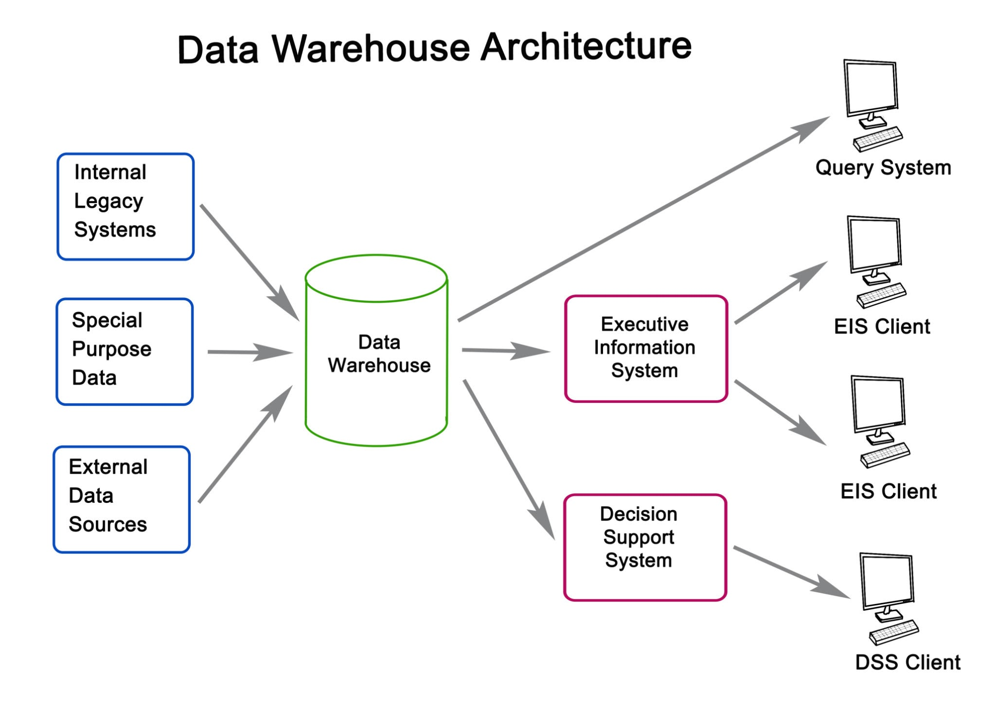
Getty Images
Explore

5. Project Outcomes
- Functional Security: Successfully implemented a 4-digit PIN requirement and an automatic lockout after 3 failed attempts.
- Financial Integrity: The system prevents "over-drafting" by checking available balances before allowing a withdrawal.
- Logical Denomination: By enforcing multiples of 500, the system mimics actual ATM hardware capabilities.
- Dynamic Updates: Users can successfully change their PIN, and the system updates the internal dictionary in real-time.

6. Conclusion
The ATM Management System project effectively demonstrates the intersection of programming logic and financial security. It provides a robust foundation for more complex banking applications, successfully handling user input errors and maintaining data consistency throughout the session.

7. Future Scope
- Multi-user Support: Implementing a list of dictionaries to handle multiple account holders.
- Transaction History: Creating a log file to record every deposit and withdrawal with timestamps.
- GUI Integration: Moving from a console-based interface to a Graphical User Interface (GUI) using libraries like Tkinter.

